

PACKET TRACER SIMULATION TOOL AS PEDAGOGY TO IMPROVE LEARNING AND TEACHING OF COMPUTER NETWORK CONCEPTS, AND ITS EFFICIENCY

Research Thesis submitted by: SAPHULELE NGCOBO
219011729

For a project in partial fulfilment of the requirements of the Advanced Diploma: in Communication Networks.

ICT Department,
Faculty of Engineering and Technology

Supervisor: MR. M. MBODILA
Co-Supervisor: Mr. Femi A. Elegbeleye

Submission Date: January 2023

Declaration

I declare that this thesis was composed by myself, and that the work contained herein is my own except where precisely stated otherwise in the text, and that this work has not been submitted for any other degree or professional qualification except as specified.

Dedication

I dedicate this work to God Almighty, my creator, my supporter, and for his wisdom he has given it to me so that I may not be alone on this journey. Throughout this program, He has been my source of strength.
I also dedicate this thesis to my Supervisor and Co-Supervisor Mr Munienge Mbodila and Mr Femi Elegbeleye who has supported me every step of the way and whose support has ensured that I put forth all of my effort to complete what I have started tirelessly.

Acknowledgements

First and the foremost I would like to pass sincere thanks to all the people who have managed to contribute and put their more effort on this study as a way of making sure that this study becomes a successful study in all angles.
However, the expression of my gratitude goes straight to my Supervisor Mr Muniene Mbodila for the positivity guidance he has put on me to make sure that I do the right thing, it has been a long journey indeed, but he managed to stood on my side and help me wherever I needed his assistance and guidance. The development he has put on me made this topic a workable one under difficulties we have been encountering.
I would like also to pass my sincere thanks to all my classmates, electrical engineering students and Butterworth Campus as whole for filling the questionnaire, if it was not because of you this study would not be a successful one the effort you have put on this study is noticeable by me.
In last I would like to thank God almighty for guiding me and giving strength not to give up as I sometimes had those mentality of giving up, but he stood by my side to make sure that what I have started I have to finish it.

Abstract

The main goal and purpose of this study was to investigate the Effectiveness of Packet Tracer tool within the Computer Networks study at Walter Sisulu University.
Previous study discovered that one of the main issues and reasons that brings difficulties and challenges in enhancing teaching and learning of Computer Networks is the lack of electronic devices and infrastructure within the institution. So, to overcome this issue within the Walter Sisulu University the Institution has to provide students with working labs so that students can be able to utilise them and familiarize them with them so that it can be their daily bread to use labs and the effective training to students will be paramount.
the achievement of the objectives of this study was done through the usage of Case Study and the methods used were the mixed method approach which comprises of qualitative and quantitative approach.
With qualitative approach questionnaire was created using google drive and has been distributed to 75 students from Walter Sisulu University Butterworth campus by sharing the link which was created.
As for quantitative method data fathered online showed that most students agreed that they are encountering an issue of lack of electronic devices and labs that makes it difficult for them to purely understand Packet Tracer which makes it difficult for them and to fail whenever they are writing exams that will have something to do with Packet Tracer. This study will help Walter Sisulu University to build better future IT Engineers and also Technologies as well for teaching and learning.

Table of Contents
Declaration 2
Dedication 3
Acknowledgements 4
Abstract 5
List Of Tables 8
List Of Figures 9
Definition Of Concepts 10
LIST OF ACRONYMS 11
CHAPTER ONE 12
INTRODUCTION AND BACKGROUND 12
1.1. Introduction 12
1.2. Problem Statement 13
1.2. Research Questions 14
1.4. Research Objectives 15
1.5. Significance of the Study 15
1.6. Literature Review 15
1.7. Research Methodology 17
1.7.1. Design 17
1.7.2. Paradigm 17
1.7.3. Approach 18
1.7.4. Sampling 18
1.7.5. Data Collection and Analysis 18
1. 8. Limitations of the Study 19
1.9. Ethical Considerations 19
1.10. Time Schedule 19
1.11. Preliminary List of Chapters 20
CHAPTER TWO 22
LITERATURE REVIEW 22
2.1. Chapter Overview 22
2.2. Related Works Background 22
2.3. Packet Tracer Modes and Features 23
2.4. Importance of Packet Tracer for Teaching Networks 25
2.5. The Use of Simulation Tools in Education 26
2.6. Benefits of Packet Tracer in Education 27
2.7. Chapter Summary 28
CHAPTER THREE 30
RESEARCH METHODOLOGY 30
3.1. Chapter Overview 30
3.2 Background Information 30
3.2. Methodology 30
3.2.1 Qualitative 30
3.2.2 Quantitative 31
3.4. Research Design 32
3.5 Data Collection Instruments 32
3.6 Population Description 33
3.6.1 Ethical Considerations 33
3.6.2 Sampling 33
3.7 Chapter Summary 34
CHAPTER FOUR 35
RESULTS AND DATA ANALYSIS 35
4.1 Chapter Overview 35
4.2. Analysis Procedure 35
4.3 Data Collection 36
4.4 Chapter Summary 41
CHAPTER FIVE 43
CONCLUSION AND RECOMMENDATIONS 43
5.1 Introduction 43
5.2 Summary of All Chapters 43
5.2.1 Chapter One Summary 43
5.2.2 Chapter Two Summary 44
5.2.3 Chapter Three Summary 44
5.2.4 Chapter Four Summary 45
5.3 Limitations 45
5.4 Conclusion 45
5.5 Effectiveness of The Study 46
5.6. Recommendation 46
References 47

List Of Tables

Table 2. 1 Comparison of Physical-work space vs Logical-work space 18
Table 2. 2 Comparison of Real-time mode vs Simulation mode 20

List Of Figures

Figure 4. 1: Gender of Participants 38
Figure 4. 2: Age of Participants 39
Figure 4. 3: Name of Departments 39
Figure 4. 4: Year of Study of Participants 40
Figure 4. 5:Occupation of Participants 40
Figure 4. 6:Ownership of device on Participants 41
Figure 4. 7:Participants views on using Packet Tracer 42
Figure 4. 8:Different types of devices owned by Students. 42
Figure 4. 9:Student's point of view on Packet Tracer updating. 43

Definition Of Concepts

Packet Tracer (PT) is a tool that offers an interactive environment for learning networking concepts and protocols, it helps students and instructors to create their own network to explore its effectiveness.
Device-to-Device(D2D) refers to the technology that enables user equipment (UE) to interact with one another, either with or without the assistance of network infrastructures like access points or base stations.
Dynamic Host Configuration Protocol (DHCP) it is a client protocol that enables Internet Protocol automatically with its Internet Protocol address, subnetting and default gateway. Without DHCP, IP address for computers that are moved from one subnet to another cannot obtain an IP address not unless configured manually.
Virtual Local Area Network(V-LAN) Is a virtualized connection that joins multiple devices and network nodes from various LANs into a single logical network. It simplifies and eases the process of managing devices.
File Transfer Protocol (FTP) is a common communication protocol used to transfer data over a computer from a server to a client.
Hypertext Transfer Protocol (HTTP) is an application-layer protocol for transmitting hypermedia documents, such as HTML.
Composable Network Application Processor (CNAP) makes the best possible use of the L1/L2/L3 caches in Intel Architecture CPUs to maximize performance and efficiency.
Domain Name System (DNS) is an internet-wide and distributed hierarchy and naming system for computers, services, and other resources.
Trivial File Transfer Protocol (TFTP) is a straight-forward lockstep file transfer protocol that enables a client to download or upload files to a remote host.

LIST OF ACRONYMS

DHCP - Dynamic Host Configuration Protocol
V-LAN – Virtual Local Area Network
FTP – File Transfer Protocol
HTTP - Hypertext Transfer Protocol
CNAP – Composable Network Application Processor
DNS – Domain Name System
TFTP – Trivial File Transfer Protocol
PT – Packet Traer
D2D – Device to Device

CHAPTER ONE

INTRODUCTION AND BACKGROUND

Introduction

Today's generations are more reliant on the digital world in their daily lives as a result of the technological uprising. The effectiveness of the digital age has altered how students view the educational system. Information and communication technology has become more popular because of the technology's impulsive growth, which has opened up opportunities for study in the field of computer networks. The computer network course is a crucial component of the Computer Science and Engineering curriculum. Teaching a course on computer networks to students is never easy because the subject matter calls for more hands-on experience than lecture. During classroom instruction, it is exceedingly challenging for students to visualize the ideas of computer networks, protocol formats, and packet flow. This software enables students to practice configuration and network design simulation without the need to use the real, expensive devices, saving operating costs for Jasin Community College, Selandar Community College, and Masjid Tanah Community College. To address the aforementioned challenge, this pedagogical practice known as active learning through simulation tool is identified in the delivery of the course.(Mohd Aznan Bin Janal et al., 2020). In literature [5] we discovered that students can create complex/large networks using the packet tracer, which is not achievable with actual hardware, and that it is helpful in grasping the fundamental network ideas. (Vijayalakshmi, Desai and Raikar, 2016).
The importance of the computer network in enhancing the teaching and learning environment cannot be overstated. Finding the optimal learning strategy for this important subject presents challenges, particularly when it comes to comprehending technical concepts and principles of routing protocol. As a result, it is necessary to look into the usefulness of employing Cisco Packet Tracer as a learning tool.(Maizura et al., 2018).
Understanding and teaching computer networking topics can be challenging because they usually include complicated and dynamic processes that are difficult to visualize and understand.(Goldstein et al., 2005).
As it was discovered that the concepts of Computer Networking can be much difficult to teach and understand especially for the beginners of this concepts, so to support the learning environment and encounter these difficulties so to make everyone to participate with understanding then this tool has been introduced to facilitate active learning among all the students by solving problems using this tool and evaluation framework to enhance deep learning environment, this tool does not only allow students to evaluate only but it also allows and helps students to design their own Network Topology structures where each student will show how much he/she understands this tool based on what it has been taught during the class session and this also needs to be taken into consideration when using this tool that better and good knowledge of using and running this tool is paramount.

1.2. Problem Statement

The current problem that the educational sector is facing on enhancing teaching and learning the Computer Network concepts is based on the understanding of the Students whereby they fail to understand onto how the configurations has gone due to the fact that they only study the theory part of it which makes it difficult to understand it, however the introduction of Packet Tracer as the Pedagogy to enhance tis learning becomes more efficient because it will assist them as to understand onto where it all begins and how to put it in place as the practical part of it. In a comparative study, Tu [15] compared Cisco Packet Tracer as a virtual experimental technique to a genuine experiment that used actual hardware. Tu came to the conclusion that Packet Tracer offers a number of advantages, including affordability, comfort, adaptability, safety, and ease of expansion, particularly before setting up a true experimental scenario.(Demeter et al., 2019).
The use of digital technology it has been increasing lately in high education. Currently with the use of eLearning, Technology has come to an option that the current educational sector depends on digital usage of Tools in our daily lives to embark a new journey to the world of 4th industrial revolution in Education.
The introduction of these digital technologies within the education sector will make a huge change in the education systems. As such the introduction of Packet Tracer Simulation Tool as Pedagogy will not only make changes on viewpoints of Students but the increment of Technological exposure will be amended and be put in place as a priority as the computer curriculum system that is based on Computer Network Engineering course that has taken a huge role to be played.
After each and every activity that has been taken by the student the evaluation is being considered as the main point to be intended to be done, the evaluation understanding of each student is based on the following aspects of Packet Tracer (PT), presentations and quizzes. These quizzes will be based on different protocols required by the course such as DHCP, SUBNETTING, V-LAN and FTP and HTTP.
In some activities by the lecturers has been made error configurations deliberately as to search and look for the understanding of each student about the course, so this Pedagogy made things easier to understand on how I would detect this error deliberately made by the lecturer to be solved which is known as troubleshooting, an example of this effect is:
i.e., router A (config-if) no ip address, when you have configured a wrong IP address of an interface that is not in the addressing table.

Research Questions

- What effect does the usage of Packet Tracer tool has to enhance learning in of Computer Networking study?
- How can packet tracer be used to introduced network concept in learning and teaching?
- How can Packet Tracer have capacitated students in understanding the concepts of Computer Networking?

1.4. Research Objectives

- To investigate the effect of packet tracer usage in enhancing students learning of Computer Networking concepts.
- To introduced student in various network concepts in learning and teaching using packet tracer.
- To assist students in using Packet Tracer using scenario that will help them understand the concepts of Computer Networking

1.5. Significance of the Study

Through this research, the students will be able to understand that the usage of this tool in Network engineering is paramount especially in the Network environment. Students and Institutions may also consider Packet Tracer tool as an important tool to solve problems within the environment on computing. This Research will demonstrate that there are difficulties that the Computer Network students encountering when designing and solving problem using Packet Tracer tool within the educational sector of this study, the main difficult is based on the version upgrades that takes place on this tool. If it can be taken into consideration that all the students who are using the tool must register their credentials within so to make things easier that when there is a new version that has been released every student who is within the system of Cisco who have been confirmed that are still an active students of particular institution can be sent the notification that acknowledge them about the new version that has been released.

1.6. Literature Review

It was described that (Rashid et al., 2016) To make the abstraction of the computer networking course that was explained by Chang (2004)., network simulation software must be used. In this research, the impact and effectiveness of network simulator in teaching and learning of computer networking will be examined. The network simulator chosen which is Cisco Packet Tracer would be adopted mainly in a lab session. Even after students finished a set of exercises and stated that they went well, it has been shown that they still struggled with subsequent challenges that required a comprehension of the earlier work. This was especially true when students were working independently and receiving no immediate or direct teacher assistance, such as while finishing practical exercises.(Goldstein et al., 2005).
Researchers has discovered that (Makasiranondh, Maj and Veal, 2010) Simulation tools are useful for modelling and evaluating network protocols and traffic. Such tools are important because it is impractical to conduct experiments on a live network. However, many simulators are primarily research tools and their use in a teaching context may be problematic [5]. One of the main problems is these tools are complex and may be difficult to use. Students, especially novices, ideally need easy to use tools that help them develop cognitive models.
Diagrammatic model representations are considered to be particularly valuable. According to the principles of Constructivism, students must construct knowledge rather than simply being recipients of information [6]. Glaserfield states:
... knowledge cannot simply be transferred by means of words. Verbally explaining a problem does not lead to understanding, unless the concepts the listener has associated with the linguistic components of the
explanation is compatible with those the explainer has in mind. Hence it is essential that the teacher has an adequate model of the conceptual network within which the student assimilates what he or she is being told. Without such a model as a basis, teaching is likely to be a hit-or-miss affair [7].
Although h the usage of the highly abstraction-levelled simulation tools for learning purposes is possible, such usage requires a further creation and modification of front-end interfaces [5][8]. Without a suitable Graphical User Interface, novices are likely to experience difficulties with these research-based simulation tools.
However, these problems largely have been addressed and so network simulators represent a low-cost method of teaching network technology. A typical network simulator allows students to design and configure a network without the need for dedicated network devices. There exists a wide range of simulators that offer different degrees of functionality and flexibility. An important criterion is that the simulator must mimic, as closely as possible, actual network device operation.

1.7. Research Methodology

1.7.1. Design

This research will make use of both qualitative and quantitative approach to research design. A questionnaire will be designed and given to selected participants which will be chosen randomly. Students of both Electrical and Information Technology department will be asked these questions to give their point of view regarding the use effectiveness of Packet Tracer.

This will be achieved by collecting information from different students and staff members through google drive link which will be sent via WhatsApp.

1.7.2. Paradigm

In this study, we will focus on the research paradigm of positivism—its definition, historic formation, components, and assumptions(Park and Artino, 2020). This study makes the case that the significance of the Packet Tracer Simulation Tool can be utilized to increase and enhance students' practical understanding of computer networking principles. Additionally, students can create small projects with more inventive and creative solutions. It has been regarded as suitable for this study within the Walter Sisulu University Engineering and Technology students are still using this tool to enhance learning and teaching among the students(Rashid et al., 2016).

The educational simulation tool Cisco Packet Tracer helps computer networking students explore and perform network tasks. Packet Tracer was introduced by the Cisco Networking Academy Program (CNAP) as a tool for computer network course teaching and learning that offers "simulation, visualization, authoring, collaboration capabilities and evaluation."(Maizura et al., 2018).

1.7.3. Approach

On this study we will be focusing on the usage of Mixed Methods Approach A combination method of quantitative and qualitative or mixed models (concurrent triangulation) is a method of research by evenly combining the two approaches, researchers may compare all of the data gathered from both approaches and draw conclusions. [17](Ambiyar et al., 2019). The purpose of this form of research is that both qualitative and quantitative research, provide more insight into a research problem or issue when combined than when either research approach is used separately. (Bulsara and Hesse-biber, 2015). Since many researchers utilize it to gather data, they can combine it with other data to better define or comprehend the issue. (Bulsara and Hesse-biber, 2015) using different formats such as interviews and surveys questions. In addition to conducting interviews with a few students or lectures to cover the qualitative portion of the study, questionnaires will be used to generate the quantitative portion of the study. A major benefit of a mixed method research methodology is that a researcher can revisit the qualitative data throughout the project and examine quotes again in the context of the bigger work. (Malina, Nrreklit and Selto, 2011).

1.7.4. Sampling

A sample of responses from the respondents will be chosen from the population of student groups who are registered within the institution and who uses Packet Tracer as a study tool and staff members of the department of Engineering and Technology.

1.7.5. Data Collection and Analysis

For data collection in this study will be gathered using questionnaire and interviews. The main aim of this data collection approach is to evaluate the current environment within the Engineering and Technology department and address some obstacles faced by the students and staff members about using Packet Tracer to enhance learning and teaching within the Computer Network environment, students and staff members will be questioned for evaluation purposes.

1. 8. Limitations of the Study

The focus of this study is based on The Effectiveness of Packet Tracer Simulation Tool as Pedagogy to Enhance Learning and Teaching of Computer Network Concepts. The study will involve students across the 3 Walter Sisulu University campuses which will result to different views on their reflection about the study.

1.9. Ethical Considerations

Participants will know the purpose and benefits behind the study before they agree and decline to join. They will be offered a choice to volunteer themselves to take part in filling out the questionnaire that will be sent to them. Anyone either staff member or student who do not feel like answering the enquiry will not be forced to do so he/she can decline that offer. Those who will accept an offer their personal identifiable data will not be collected.

1.10. Time Schedule

SCHEDULE
Activities | May 2022
Proposal |  | June 2022
Chapter 1:  Introduction |  |  | JULY 2022
Chapter 2:  Literature Review |  |  |  | August 2022
Chapter 3:  Methodology |  |  |  |  | Sept 2022
Chapter 4:  Findings and Discussions |  |  |  |  | Oct 2022
Chapter 5:  Conclusion |  |  |  |  | Nov 2022

Submissions

1.11. Preliminary List of Chapters

Below is the structure of this thesis:
Chapter 1
Revised proposal (introduction and overview of research work)
Chapter 2
Literature Review (in depth literature linking problem space to past researchers)
Chapter 3
Research Methodology (system approach to research study)
Chapter 4
Findings and Discussion (results of data collected and review of analysed data)

Chapter 5
Conclusion and Recommendations (research discovery and proposal for future research in-line with discovery)

CHAPTER TWO

LITERATURE REVIEW

2.1. Chapter Overview

This chapter discusses an existing literature on the use and Effectiveness of Packet Tracer tool within the teaching and learning of Computer Networks concepts in education. This review was conducted using various research articles and other projects in the area of Computer Networks simulation tool in education. This review focuses on various aspects on the use of Packet Tracer and its impact, and its effectiveness in teaching Network concepts education. The following section presents the background and discusses various literature that was used in this study.

2.2. Related Works Background

Many researchers have addressed this issue of the effectiveness of Packet Tracer as a tool of teaching and learning enhancement within higher institutions from different point of views. Packet Tracer is a cross-platform visual simulation tool developed by Cisco Systems that allows users to create network topologies to mimic modern computer networks.
Packet Tracer also regarded as an open source platform to help students to learn network concepts more clearly by creating different network scenarios(Javid, 2014).
The recognition of Packet Tracer as a tool to enhance teaching and learning of Computer networks has positively influenced the environment of Computer networks and the university curriculum. Packet tracer has two types of workspaces within the curriculum: Physical work-space and logical work-space.
Physical work-space refers to what it looks like in the real world, showing that there are geographic mapping capabilities and different network devices connected to different locations in a city.
Logical work-space : referred to building logical network topologies using drag and drop of various devices into the logical workspace(Javid, 2014).The following table shows a clear difference between these two work-spaces according to( Jangra, 2014).

Table 2. 1 Comparison of Physical-work space vs Logical-work space
Logical work-space | - Switches, Hubs, Routers, Wireless access, Hosts.  - Multi-user remote network.  - Network topology creating.  - Devices: Real, Modular with customizable image and Generic
Physical work-space | - Images for devices custom and scalable.  - Ethernet cable length display.  - Wireless association management.  - Structured cabling.  - Hierarchy of devices.

According to Kdqj and Xlolqj (2012) they have agreed that Packet Tracer permits students to build, configure, and troubleshoot networks using virtual networks(Kdqj et al., 2012), which therefore means that with no Packet Tracer there will be no success of network troubleshooting would be in place.

2.3. Packet Tracer Modes and Features

According to Anderson(Anderson, 2018), Cisco Packet Tracer offers two modes of operation for visibility into network behaviour which are as follows: Real-time mode and Simulation mode.
In real-time mode, devices on the network look and behave exactly like real Cisco devices, allowing students to practice configurations. Simulation mode allows you to see, control, and analyse the time intervals and propagation of data on your network, and learn how to troubleshoot network errors(Cabarkapa, 2015). Which means that the more technology upgrades the more the value of Packet tracer usage grows dramatically so students can easily understand the functions and processes of routing protocols(Maizura et al., 2018).

According to (Jangra, 2014) the following figure illustrates the difference in modes comparison between Real-time mode and Simulation mode.

Table 2. 2 Comparison of Real-time mode vs Simulation mode
Real-time mode | - Real time protocol updates  - Menu based configuration of DHCP, DNS, HTTP, TFTP  - Medium fidelity
Simulation mode | - Packet animation  - OSI model, Device table views and Detailed PDU  - Global event list

Packet Tracer as a simulation tool for teaching and learning within the Computer Network environment has different features as follows according to (Janitor, Jakab and Kniewald, 2010). The following are some of the features that are used in Packet Tracer
- User friendly Command Line Interface - Is one of the Packet Tracers features, when configuring directly in CLI mode, Packet Tracer simulates the CLI of a real device with nearly identical functionality which means that what will the real device do can be easily seen on Packet Tracer simulation.

- Global event list – Another Packet Tracer simulation feature that shows all data exchanged between two or more devices.
The more the current Technology gets an upgrade so as well Packet Tracer does, as the update and upgrade be in place Packet Tracer has been upgraded to a new 5.0 version of Packet Tracer. There are features which were introduced after the release of version 5.0 which are as follows:
Multiuser Capability - This feature brings a creative and collaborative way of working and builds team games among students.

- Integrated Help and Tutorials - Built-in help and tutorials provide step-by-step instructions for new Packet Tracer users.

- Activity Wizard - Is a feature that allows teachers to create assignments and practice tests for their students.

- Multiple languages - Support allows you to create your own localized version of Packet Tracer.

2.4. Importance of Packet Tracer for Teaching Networks

The computer network has recently become crucial for the operations of all organizations worldwide(Shi et al., 2020).
According Flifel on the research paper has discussed the importance of Packet Tracer for teaching network concepts and the following importance were found on his paper(Flifel, 2019):
- Establishing end-user device connectivity within a network.
- Allows users to simply drag and drop components to construct and perform the topology.
- With this drag and drop system of constructing a network topology determines how fully student understood the concepts of using Packet Tracer and be able to determine the speed at which student goes when using Packet Tracer. This helps students to understand about what is required based on the scenario and what to be done and the types of devices need to be connected as per the statement and request.

2.5. The Use of Simulation Tools in Education

Simulation can be defined in so many ways however, Klingstam and Gullander (1999) agreed that Simulation can be defined as the process of designing a model of a real system We use this model to conduct an experiment,
To understand how the system works and to evaluate different strategies for operating the system(Klingstam and Gullander, 1999).

This simulation is being used within the educational context so to enhance teaching and learning of Computer Networks, according to Brigas (2019) there are several types of simulation models that can be used within the educational context which are as follows: Qualitative model and Quantitative model.
A quantitative model consists of entities represented numerically and the relationships between the entities are described by mathematical relationships(Brigas, 2019).
Qualitative modelling allows the representation of complex dynamic systems that show only the essential features of structure and behaviour, with little information available(Brigas, 2019).
With the assistance of Quantitative model in education especially in Computer Networks brings further assistance among students to determine the amount of data transferred among the hosts so that each device can be improvised of the amount of data required and to prevent the amount of traffic when data is being transferred among these hosts.
When the connection of hosts takes place there must be a relationship between these hosts so that the mission of connection can be met. So, in that case to make sure that this is met in all angles Qualitative model must be put in place.
For an example when connecting a switch to a router there is a relationship between these two hosts but if you connect an IP Phone straight to the tower that is out of relationship.

2.6. Benefits of Packet Tracer in Education

According to Pang(2003), research on network intrusion detection benefits greatly from the use of Packet Tracer(Pang and Paxson, 2003).So this Research was conducted to investigate the Effectiveness of Packet Tracer in the Higher Learning of Education. The objectives that this study focuses on is as follows: to outline as to how does Packet Tracer affects the outcomes and the quality of the Higher Learning environment and its effectiveness.
The results of this study showed that Packet Tracer has positively impacted the higher education sector and the Education itself has benefited in the simplification of network devices connectivity and understanding of the course to all levels of study.
An easier interface for configuring the required devices is provided by Packet Tracer especially for beginners(Trabelsi, 2019).
Following are some benefits of Packet Tracer according to Allison(Allison, 2022):
- Enables the modelling and representation of reality and it enables its users to emulate the Cisco routers' settings.
- You do not need to take it around; it can be utilized any place.
- There is little or no noise, and there is also less electrical consumption.
- Provides a variety of features that mimic the actual world a secure setting for security education.
- Can help institutions save money (e.g., it can negate the need to upgrade lab equipment as often).
- Reduces the need for as much lab infrastructure and equipment, reducing space.
- The most recent hardware is periodically added to Packet Tracer so that students can simulate.
- Without networking equipment, students can complete lab exercises at home.
- Enables students to work with extensive complicated topologies.
- Tests and evaluations of student learning are helpful as well it encourages cooperation between teachers and students.
- Develop the student’s capacity for critical, creative, and problem-solving thought.
This software program permits you to simulate the configuration of Cisco routers and switches through the usage of a simulated command line interface.
Some of the objectives of cisco packet tracer are:

- Enable students to design complex networks.
- Enable students to use them as learning aids.
- Enable students to explore IoT concepts.
- Enable students to explore smart cities by providing different smart objects that use them and smart homes.
- Provides realistic visualization and simulation of IoT devices.

2.7. Chapter Summary

Device-to-Device(D2D) linkages can be created between mobile User Equipment (UEs) connected to different evolved NodesB(eNBs) or between mobile UEs connected to the same microcell, picocell, or femtocell(Etworks et al., 2014). Which means that with the assistance of D2D a student can be able to connect devices of the same amount of data consumption so that data transferred cannot be interfered by any host from other network. According to research on using Packet Tracer frequently as a tool to enhance learning and teaching of Computer Networks students get a lot of confidence to work on real-time networking devices after doing more practice with Packet Tracer networking situations(Cabarkapa, 2015).

CHAPTER THREE

RESEARCH METHODOLOGY

3.1. Chapter Overview

This chapter focuses on the methodology and methods used for data collection and analysis as well as other techniques used in this study to represent the findings of this study information among the students based on the Effectiveness of Packet Tracer tool as a pedagogy to enhance teaching and learning of computer network concepts at Walter Sisulu University (WSU).

3.2 Background Information

This chapter explain different stages that was used to conduct current research such as Research design, Data collection, Data analysis and Limits and ethical issues of the study. Learning the numerous methods that can be applied in conducting research, as well as tests, experiments, surveys, and critical studies, is a part of research methodology(Sam, 2012). With scientific methods, this research aims to find answers to open-ended questions. The main objective of study is to discover the truth, which is concealed and has not yet been discovered. (Patel and Patel, 2019).

3.2. Methodology

3.2.1 Qualitative

In this method, a researcher creates a comprehensive, complex image, examines language, records the informants' in-depth opinions, and carries out the research in a natural environment( Migiro and Magangi, 2011). The researcher is both the subject and the object of his investigation in qualitative studies. The goal of the qualitative methodology is to generate in-depth and illustrative data in order to comprehend the different facets of the subject being studied(Almeida, 2017).

3.2.2 Quantitative

The researcher uses numerical data to test the relationship between the variables while using the quantitative approach( Migiro and Magangi, 2011). Data collected in this method can be converted into usable statistics. Under this method there are different types of data collection that can be used by researchers which are as follows, face-to-face interviews, telephone interviews and an online survey can be used within this method. In collecting data, quantitative research uses formal tools and systematic processes. Data are systematically and impartially gathered(Almeida, 2017).
According to Almalki defined mixed method as the kind of research where a researcher combines components of qualitative and quantitative research approaches for the general goals of breadth and depth of understanding and evidence(Almalki, 2016).
Data collected with these two methods will be analysed as per each method so to validate if gathered data is correct and valid.
According to Patton (2002), research that exclusively employ one method are more subjected to errors associated with that specific approach than studies that use numerous methods.
Researchers can explore various viewpoints and ecological levels, contextualize trends, compare and triangulate various data, and evaluate both processes and results by utilizing mixed methods(Brown et al., 2015).
Campbell and Fiske recommended combining techniques to precisely assess a psychological characteristic(Bliss, 2003)
Sofaer(1999) argues that it is possible to gather the information required for experimental research using qualitative methods(Sofaer, 1999).
In provision of clear understanding of the study qualitative method has been used so to gain an understanding of each participant and their attitudes towards the usage of Packet Tracer as well as the motivations they have about this tool.
Questionnaire was sent to the participants of different department that are involved in using this tool where we were asking the participants about difficulties they do encounter when they are using this tool and as well as what motivates them to use it frequently not in class only but also during their spare time.
Quantitative research is the numerical representation and manipulation of observations with the purpose of describing and interpreting the phenomena those observations reflect (Kamolson, 2007).
50 students were asked through questionnaire that was sent to them via google drive in conjunction with the usage of quantitative research, it has been discovered that not all the 50 students managed to answer this questionnaire due to their own basic and personal reasons as it has been notified that any participant is allowed to refuse in answering this questionnaire.

3.4. Research Design

In order to analyse and evaluate data was gathered from the respondents’ sides and their point of view a survey research data collection method was used.
The goal of this study is to look at the Effectiveness of Packet Tracer tool as pedagogy to enhance teaching and learning of Computer concepts on Walter Sisulu University (WSU) students. Questionnaire will be used to collect this data from the students of Walter Sisulu University Ibika Campus.

3.5 Data Collection Instruments

As per the usage of mixed method approach in this study, data will be collected through interviews with the assistance of qualitative approach and we will use quantitative approach to collect data through questionnaires, questionnaires will also be used in both methods to collect data.
Rating questions with a given scale will be used, closed-ended questions will also be used which will restricts participants on setting the number of responses.

3.6 Population Description

The designed survey on this research will be carried out at the Walter Sisulu University Ibika campus located at Butterworth in the Eastern part of the Eastern Cape province. This campus comprises of different and many departments, but this study is interested on two of their departments which are Electrical Engineering and Information and Communication Technology (ICT) because these are the only departments that uses Packet Tracer for learning and teaching including their respective staff members so to evaluate onto how this tool affects their students.

3.6.1 Ethical Considerations

The anonymity of the respondents to the survey sent to them via google form with the attached letter within accompanying the questionnaire will be taken into considerations, this letter will clarify the objectives of the survey and the necessity of students to participate on this questionnaire. The respondents will be given a choice of when answering the questionnaire can put their point of views based on the answered questions.
Respondents should be made aware of their fundamental rights, such as the ability to refuse to answer any questions or to withdraw their consent at any moment(Qu and Dumay, 2011).

3.6.2 Sampling

The investigation will be based at the Butterworth campus according to the academic departments that utilize Packet Tracer within their studies, the division of these groups will be as follows: Electrical Engineering and Information and Communication Technology (ICT) department among the students who are doing their 2nd, 3rd year of study and Advanced Diploma students within ICT while in Electrical Engineering we will be focusing on students who are doing their 1st and 2nd year study.

3.7 Chapter Summary

This chapter brings the overall research design and Methodology of this study in a sense that it shows what will be done and how will it be done, and which methods will be used to gather data and how questionnaire will be piloted to the participants. This will be done to just give a clear picture to the readers of the study on what does this research entails. It will then make sure that the questions that have been selected by the researcher are clear so to precisely show and see the importance of this study within the specified problem by the study.

CHAPTER FOUR

RESULTS AND DATA ANALYSIS

4.1 Chapter Overview

This chapter provides a fully description of data collected from an online poll that was provided and given to the Walter Sisulu University students which was evaluated using the quantitative data using the google Forms and was analysed and presented as the form of report within this study it was then classified utilizing pie charts and graphs.

4.2. Analysis Procedure

The questionnaire that was distributed among all the Walter Sisulu University students who are familiar with the usage of Packet Tracer Tool was developed using google form. By using this method of data collecting, it was hoped to increase the accuracy of the data while ensuring fairness and predictability. The dissertation's appendices provide all the information concerning questionnaires.
This questionnaire aims to fish about students’ perspectives on the usage of Packet Tracer Tool for teaching and learning, difficulties they encounter and the lack of device availability among students as to assist them on in utilizing this tool. One of the main issues is that the fact that some Packet Tracer activities when you configure them the score board does not increase and yet the command is correct, so it gives more concern among the students as to maybe the command is not the one required within this question.

4.3 Data Collection

The following data was collected and obtained from questionnaires which was submitted to the Walter Sisulu University based on this study quantitatively.
4.3.1 Section A: Participants Personal details.
The above section is meant to obtain the personal details of the students considering the anonymity of the students within this study so that they can be free to answer all required questions by the study with no fear that they might be known.
According to the pie chart below in figure 4.1 shows the results that 60% respondents come from females while 33.3 % comes from males and furthermore 6.7% is from bisexual students within the department of Engineering and Technology who managed to complete the distributed questionnaire.
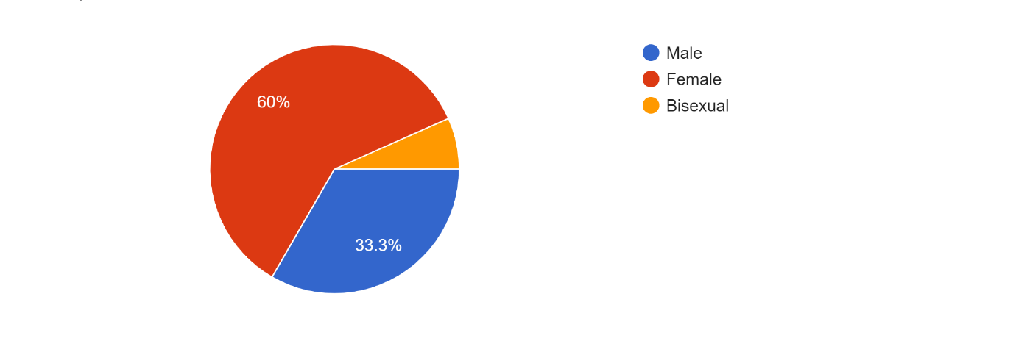
Figure 4. 1: Gender of Participants

As the institution consists of different people’s background, culture, race and many more but on this study the researcher was interested in knowing the age of the participants within this study and the following figure 4.2 below illustrates the active respondents on the questionnaire of this study based on their age group as per the interest of the researcher. According to the below figure states that more active students on this questionnaire were students from 25 years and above with 46.7% followed by both ages of from 18-21 years and 22-24 years with the same activeness of 26.7%.

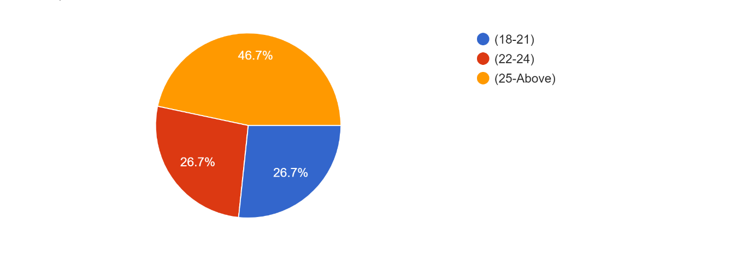
Figure 4. 2: Age of Participants

As Walter Sisulu University comprises of different departments of different courses, this study is based on 2 courses within the Department of Engineering and Technology which are Electrical Engineering and ICT, the below figure 4.3 shows the activeness and the participation made by these students from these courses. The below statistics shows that 92.9% were students from ICT while 7.1% shows the activeness of students from Electrical Engineering course, this shows that students from ICT use most frequently this tool (Packet Tracer) than Electrical students.
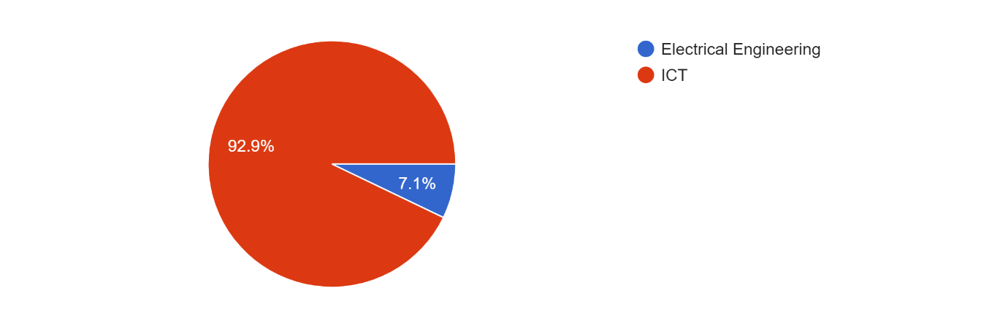
Figure 4. 3: Name of Departments

In Walter Sisulu University the introduction of Packet Tracer to students is being done at 2nd year of study as the below pie chart displays the full outcome of the said statement as it shows that 1st years students participation is 0% because they have not been introduced to the usage of this tool, however, the below figure shows that 3rd year students has more impact on piloted questionnaire with 73.3% followed by the Postgrad students with 20% participation then second year students with 6.7%.
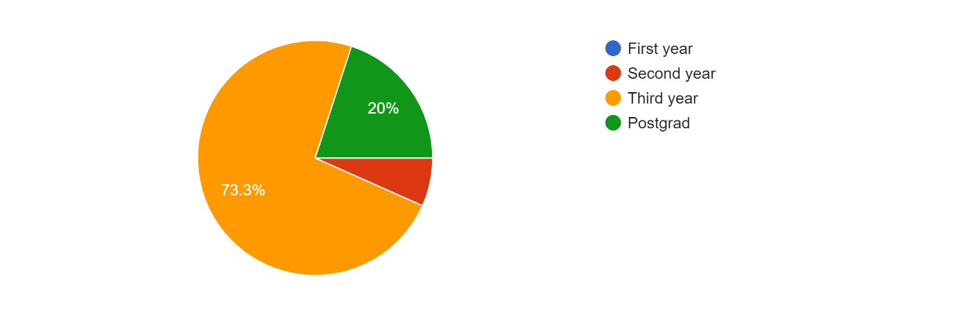
Figure 4. 4: Year of Study of Participants

The effectiveness of this tool as to be evaluated among the lecturers and as well among the students of both departments, after the evaluation took place, figure below shows the outcomes from both students and staff members which are lecturers. Students came up with the participation of 93.3% while 6.7% is from staff members.
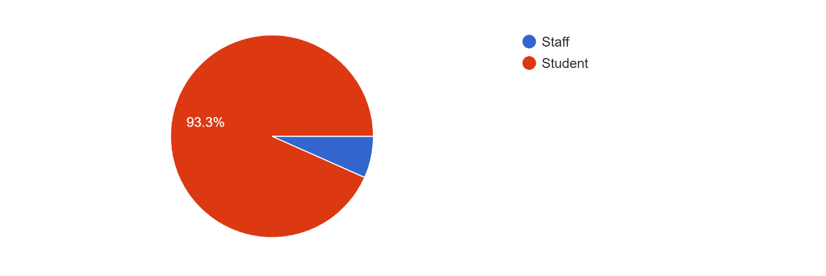
Figure 4. 5:Occupation of Participants

The effectiveness of Packet Tracer cannot be seen without an intermediary device that will offer an access to students so to utilize the tool, this study has shown an interest on investigating about the availability and ownership of these required devices among the students so to access the tool. After the pilot of questionnaires to the students the below outcomes on figure were obtained.

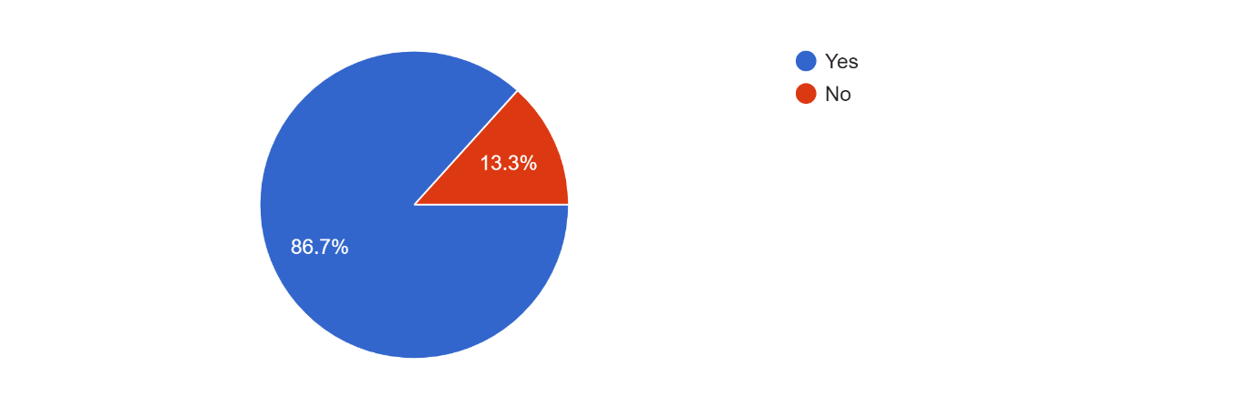
Figure 4. 6:Ownership of device on Participants

4.3.2 Section B: Issues Identification
The focus of this study is based on the issues that the students face when using Packet Tracer and the challenges they encounter not only on challenges but also the experience they do have about this tool and their technical knowledge and the affection of the Packet Tracer in their academics either positive or negative effect.
The below bar graph shows the response of students about the issues they do encounter when they are using Packet Tracer. It shows that with a scale of 1:5 almost 40% of the students do encounter moderate issues with Packet Tracer when they are utilize it.

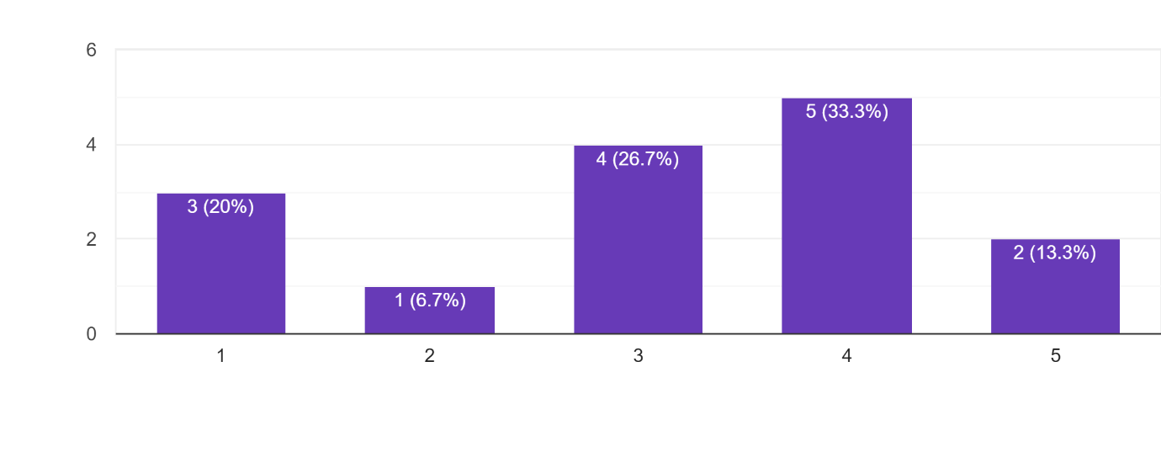
Figure 4. 7:Participants views on using Packet Tracer

Due to the lack of devices among the students this study as to investigate about the devices that are being used by the students when configuring the figure below comprises of the outcomes of the investigation that was conducted based on 3 different types of devices which are Tablets, Laptops and Smartphones.
Based on the analysed statistics none of the students who uses Tablets for configurations whereas 86.7% are students who are using Laptops to configure and 13.3% falls on students who use Smartphones to configure.
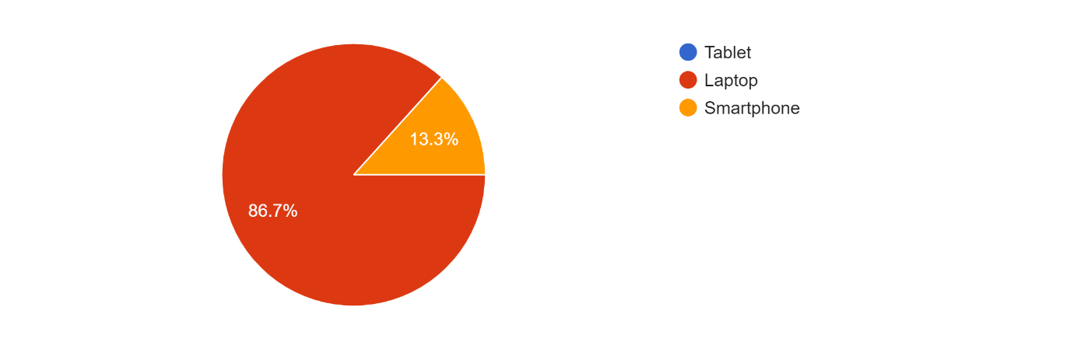
Figure 4. 8:Different types of devices owned by Students.
As the time goes by also the Technology advances, so that will the new updates to take place on different Software such as this tool Packet Tracer, so there are some activities which will require a new version of Packet Tracer for compatibility. The following figure show the evaluation that was made to gather the information about the new available Packet Tracer version among the students. The figure below it furthermore shows that 40% of the student populace who have taken part on this questionnaire do have the new version, Packet Tracer.
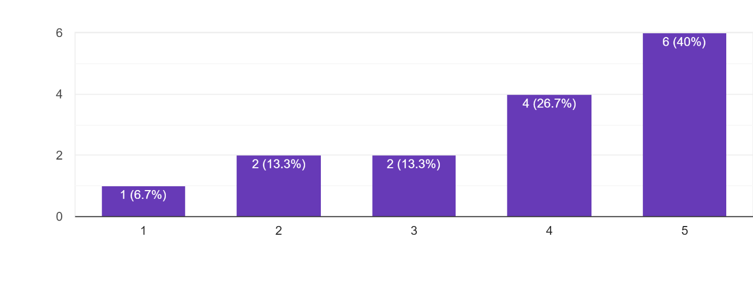
Figure 4. 9:Student's point of view on Packet Tracer updating.

This study as furthermore evaluated the effectiveness of Packet Tracer to the Students in terms of how Packet Tracer assists them to enhance learning and understanding of the course, according to the below graph it show that 80% of the student populace got an assistance from the tool so to understand the course. The figure below briefly illustrates all these outcomes.

4.4 Chapter Summary

This Chapter describes the tools and as well as the form of data collection used to gather data from the participants from different study levels and courses which uses Packet Tracer as a tool of enhancing teaching and learning of Computer Networks to answer useful questions related to usage of Packet Tracer within the environment of Computer Networks. According to John(2007) Tables like the ones shown above and the use of quotations in written documents are two examples of how findings might be presented(Kairuz, Crump and John O’brien, 2007). The above tables and graphs represent the outcomes of the responses from the participants of the departments included which are Electrical Engineering and Information and Communication Technology.

CHAPTER FIVE

CONCLUSION AND RECOMMENDATIONS

5.1 Introduction

Within the Department of Engineering and Technology mainly at the Walter Sisulu University campuses Buffalo City Campus, Butterworth campus and Queenstown campus comprises of the courses which acquire the usage of Packet Tracer as the part and parcel of the tool of study to enhance learning and teaching of computer concepts mainly these courses are Electrical Engineering and Information and Communication Technology.
The statics of data gathered from the students shows that there is a huge challenge that students and lecturers do face when they have to utilize Packet Tracer on their laboratories due to the fact that most of these laboratories does not have computer desktops to assist students so to push themselves on studying further about Packet Tracer.
Therefore, the findings of this study will assist the institution to make an assurance that what is required to assist its students for their studies must be put in place. The focus of this chapter alone is to summarise all the chapters of this study starting from the first chapter the introduction of the problem to the fourth chapter that comprises of Data collection and Data analysis.

5.2 Summary of All Chapters

5.2.1 Chapter One Summary

In this chapter, we have introduced the problem of this study by explaining in detail the occurrence which has been identified in the problem statement of this study, which regarded as the challenge within the Walter Sisulu University students and lecturers as large due to the lack of laboratories within the institution which is the main problem that student of the institution face when it comes to the practical session of computer networks through Packet Tracer. The format into which the submission of the chapters was introduced in this chapter and the tools which will be used to collect data was also mentioned on this chapter with the importance of this study as well.

5.2.2 Chapter Two Summary

The findings of previous of research on the Effectiveness of Packet Tracer tool as a pedagogy to enhance learning and teaching of computer network concepts which has been conducted by various researchers. Some of the conducted studies was to investigate on the impact that has been caused within the institutional performances of the students due to lack of this tool which its main purpose is to capacitate them with full understanding of practical session of this study. Learning about computer networks involves more than just studying theoretical concepts. Because there are many configurations and concepts that must first be comprehended, students will find it difficult to apply a theory, particularly in light of routing protocol(Kdqj et al., 2012).

5.2.3 Chapter Three Summary

In this chapter we present the overall design and methodology of this study and clearly demonstrates on what will be done and as to how that will be done concurrently of the study. The main aim and goal of this chapter is to make sure that it is clearly demonstrated to the readers so that they can clearly understand what the study entails and comprises of and the objectives of the study as well as the importance of this study within the stated problem and its area of interest.

5.2.4 Chapter Four Summary

This chapter shows and demonstrate on how data will be collected in terms of different methods of data collection which is quantitative method and qualitative using an online survey to collect this data. The collected data was gathered, summarized and examined based on the stated problem of the Effectiveness of Packet Tracer tool within the Walter Sisulu University. This chapter uses research questions that were asked, to the participants and the material that was collected.

5.3 Limitations

There was a desired number of participants on this study which was at least 75 participants can participate on the online survey which was given to them as a form of collecting quantitative data of the study which identifies the problem of the statement that has been mentioned on chapter 1.
However, the researcher did not manage to obtain the required and proposed number of participants on both qualitative and quantitative surveys, it has been discovered that only 25 participants managed to answer these questions for quantitative findings, and it shows that the huge number of these participants comes from the department of Information and Communication Technology.
These interviews were scheduled to be done and conducted online to obtain quantitative results from the participants but due to the lack of data and the issue of loadshedding became a blockage for this study to be successfully done so. The statistics of the non-respondent participants questioned the researcher on how much contribution could be caused by them in this study, but because they only depend on the institution’s data provision they cannot buy themselves.

5.4 Conclusion

On the conclusion of this study, this chapter finishes the research investigation, and it summarises the brief overview of the study findings based on the data obtained from the participants that managed to receive this questionnaire for data collection purposes. The aim of this study was to give a clear direction and plan on how the institution Walter Sisulu University can do in order to make sure that their students graduate with full understanding of this tool and how can they capacitate them and to overcome this issue by provisioning the laboratories of good conditions and updated tool.

5.5 Effectiveness of The Study

Dawn saw ICT as a mechanism for facilitating teaching, not for enhancing student learning(Bate, 2010). As per the wish of each department for their students, the use of Packet Tracer among students can bring more positivity to the students’ achievements if it will be used accordingly and appropriately. This use of Packet Tracer to the field of Engineering and Technology also increased the self-study of the students due to the fact that they can study on their own perfect time with no intervention of teachers and anyone but alone themselves.

5.6. Recommendations

This study found that students from first year study to their final year of study third year are encountering issues in using and understanding of Packet Tracer in the labs of the institution due to the fact that there is a lack of infrastructure to capacitate and help those needy students to study within the premises of the institution so that they can be helped by their instructors. Therefore, it is recommended that the institution should be making sure that they do provide students with the needy devices so that they can not wonder around the campus not knowing what to do so that they can do their activities using Packet Tracer.
Troubleshooting of the current devices can also be an assistance for each and every lab the institution.

References

- Allison, J. (2022) ‘Simulation-Based Learning via Cisco Packet Tracer to Enhance the Teaching of Computer Networks’, 4646, pp. 0–1.
- Almalki, S. (2016) ‘Integrating Quantitative and Qualitative Data in Mixed Methods Research—Challenges and Benefits’, Journal of Education and Learning, 5(3), p. 288. doi:10.5539/jel.v5n3p288.
- Almeida, F. (2017) ‘STRENGTHS AND LIMITATIONS OF QUALITATIVE AND’, (September). doi:10.5281/zenodo.887089.
- Ambiyar et al. (2019) ‘Evaluation of packet tracer application effectiveness in Computer Design Networking subject’, International Journal on Advanced Science, Engineering and Information Technology, 9(1), pp. 54–59. doi:10.18517/ijaseit.9.1.5931.
- Anderson, P.K. (2018) ‘Cisco Packet Tracer as a teaching and learning tool for computer networks in Cisco Packet Tracer as a teaching and learning tool for computer networks in DWU Picky Airi’, (December).
- Bate, F.G. (2010) ‘The role of ICT in the pedagogical transformation of primary teachers: Dream, aspiration, reality’, ED-MEDIA World Conference on Educational Multimedia, Hypermedia and Telecommunications. Toronto, Canada [Preprint].
- Bliss, L.A. (2003) ‘Taking the Next Step : Mixed Methods Research in Organizational Systems’, (January).
- Brigas, C.J. (2019) ‘Modeling and Simulation in an Educational Context: Teaching and Learning Sciences’, Research in Social Sciences and Technology, 4(2), pp. 1–12. doi:10.46303/ressat.04.02.1.
- Brown, K.M. et al. (2015) ‘Searching for rigour in the reporting of mixed methods population health research: A methodological review’, Health Education Research, 30(6), pp. 811–839. doi:10.1093/her/cyv046.
- Bulsara, C. and Hesse-biber, S. (2015) ‘APPROACH TO ENHANCE AND APPROACH TO ENHANCE AND Dr Caroline Bulsara , Brightwater Group Research Centre Manager & Adjunct Senior Lecturer , Notre Dame University’.
- Cabarkapa, D. (2015) ‘Application of Cisco Packet Tracer 6.2 in teaching of advanced computer networks’, International Conference on Information Technology and Development of Education – ITRO 2015 June, 2015. Zrenjanin, Republic of Serbia Application, (June), pp. 1–5. doi:10.13140/RG.2.1.4881.6802.
- Demeter, R. et al. (2019) ‘A quantitative study of using Cisco Packet Tracer simulation software to improve IT students’ creativity and outcomes’, 10th IEEE International Conference on Cognitive Infocommunications, CogInfoCom 2019 - Proceedings, pp. 353–358. doi:10.1109/CogInfoCom47531.2019.9089920.
- Etworks, L.D.N. et al. (2014) ‘AND B EYOND C ELLULAR N ETWORKS D EVICE - TO -D EVICE C OMMUNICATIONS A CHIEVE E FFICIENT L OAD B ALANCING IN’, (April), pp. 57–65.
- Flifel, R.K. (2019) ‘IS e C ure’, pp. 1–4.
- Goldstein, C. et al. (2005) ‘Using a Network Simulation Tool to engage students in Active Learning enhances their understanding of complex data communications concepts .’, 42(c).
- Jangra, B.S. (2014) ‘“ Cisco Packet Tracer : a Securing Techniques for Wired or Wireless Network ” Abstract :’, 4(9), pp. 1–12.
- Janitor, J., Jakab, F. and Kniewald, K. (2010) ‘Visual Learning Tools for Teaching / Learning Computer Networks Cisco Networking Academy and Packet Tracer’, pp. 351–355. doi:10.1109/ICNS.2010.55.
- Javid, S.R. (2014) ‘Role of Packet Tracer in learning Computer Networks’, (July).
- Kairuz, T., Crump, K. and John O’brien, A. (2007) ‘Perspectives on qualitative research. Part 2: Useful tools for data collection and analysis Medication review among older people View project Mental Health and Diabetes View project’, Article in Pharmaceutical Journal [Preprint], (March). Available at: https://www.researchgate.net/publication/43499524.
- Kamolson, S. (2007) ‘Fundamentals of quantitative research Suphat Sukamolson, Ph.D. Language Institute Chulalongkorn University’, Language Institute, p. 20. Available at: http://www.culi.chula.ac.th/e-Journal/bod/Suphat Sukamolson.pdf%5Cnhttp://isites.harvard.edu/fs/docs/icb.topic1463827.files/2007_Sukamolson_Fundamentals of Quantitative Research.pdf.
- Kdqj, R. et al. (2012) ‘7HDFKLQJ , QQRYDWLRQ LQ & RPSXWHU 1HWZRUN & RXUVH IRU’, 2, pp. 504–510. doi:10.1016/j.ieri.2012.06.124.
- Klingstam, P. and Gullander, P. (1999) ‘Overview of simulation tools for computer-aided production engineering’, Computers in Industry, 38(2), pp. 173–186. doi:10.1016/S0166-3615(98)00117-1.
- Maizura, N. et al. (2018) ‘Effectiveness of Using Cisco Packet Tracer as a Learning Tool : A Case Study of Routing Protocol’, 8(1). doi:10.18178/ijiet.2018.8.1.1004.
- Makasiranondh, W., Maj, S.P. and Veal, D. (2010) ‘Pedagogical evaluation of simulation tools usage in Network Technology Education’, 8(3), pp. 321–326.
- Malina, M.A., Nrreklit, H.S.O. and Selto, F.H. (2011) ‘Lessons learned: Advantages and disadvantages of mixed method research’, Qualitative Research in Accounting and Management, 8(1), pp. 59–71. doi:10.1108/11766091111124702.
- Migiro, S.O. and Magangi, B.A. (2011) ‘Mixed methods : A review of literature and the future of the new research paradigm’, 5(May), pp. 3757–3764. doi:10.5897/AJBM09.082.
- Mohd Aznan Bin Janal, R. et al. (2020) ‘Title : the Effectiveness in Using Packet Tracer Simulation Software in Improving the Skills Among Computer System and Networks Programme Students’, International Journal of Technical Vocational and Engineering Technology, 2(1), pp. 2710–7094.
- Pang, R. and Paxson, V. (2003) ‘A high-level programming environment for packet trace anonymization and transformation’, p. 339. doi:10.1145/863955.863994.
- Park, Y.S. and Artino, A.R. (2020) ‘The Positivism Paradigm of Research .’, 95. doi:10.1097/ACM.0000000000003093.
- Patel, M. and Patel, N. (2019) ‘Exploring Research Methodology: Review Article’, International Journal of Research and Review Keywords: Research, Methodology, Research Methodology, 6(3), pp. 48–55. Available at: www.ijrrjournal.com.
- Qu, S.Q. and Dumay, J. (2011) ‘The qualitative research interview’, Qualitative Research in Accounting and Management, 8(3), pp. 238–264. doi:10.1108/11766091111162070.
- Rashid, A. et al. (2016) ‘Cisco Packet Tracer Simulation as Effective Pedagogy in Computer Networking Course’, pp. 4–18.
- Sam, G. (2012) ‘Chapter 3 – Research Methodology and Research Method’, Research Methodology and Research Method, (March 2012), p. 43.
- Shi, R. et al. (2020) ‘Role of packet tracer in simulating server services on the client-server computer network Role of packet tracer in simulating server services on the client-server computer network’. doi:10.1088/1742-6596/1511/1/012007.
- Sofaer, S. (1999) ‘Qualitative methods: what are they and why use them?’, Health services research, 34(5 Pt 2), pp. 1101–18. Available at: http://www.ncbi.nlm.nih.gov/pubmed/10591275%0Ahttp://www.pubmedcentral.nih.gov/articlerender.fcgi?artid=PMC1089055.
- Trabelsi, Z. (2019) ‘Exploring the Opportunities of Cisco Packet Tracer For Hands-on Security Courses on Firewalls’, pp. 411–418.
- Vijayalakshmi, M., Desai, P. and Raikar, M.M. (2016) ‘Packet Tracer Simulation Tool as Pedagogy to Enhance Learning of Computer Network Concepts’, pp. 71–76. doi:10.1109/MITE.2016.16.

